Arthur Township
1899 Frontage Road
Mora, MN 55051

Swing-Away Mailbox Post Application

Name:_________________________________ Phone Number:__________________________
Address:________________________________
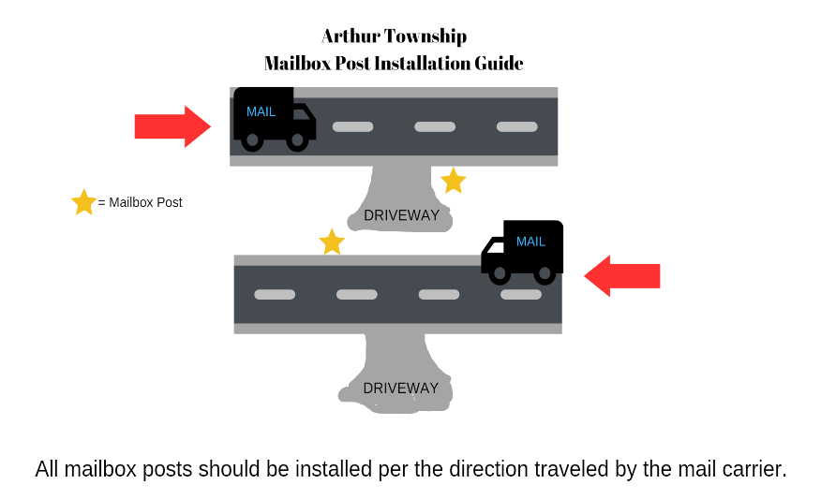
Requested date to receive mailbox:
______________________________________
Resident needs:
Mailbox Swing-Away Standard
With MN DOT approved Post: $100.00

Please fill out application and send payment to:
Arthur Town Hall
1899 Frontage Road
Mora, MN 55051

Resident agrees to and understands the information written herein; that Arthur Township does not install mailbox posts and does require payment before issuance of products.

_____________________________________________________________________________________
Sign Date

Upon receipt of application and payment, an agent of Arthur Township will contact you to set up a time for approval of installation. Installation of mailbox posts and standards is at the discretion of the property owner; Arthur Township and its agents, do not provide installation. Please call or email the clerk with any questions: 320-679-1347 or arthurtownhall@gmail.com

Office use only:

Date application was received: ____________________ Date payment was received:________________

Date of owner installation:______________________ Received by:_____________________________
